|  |
| --- |
|  |
| FSA ID |
|  |
| |  |  | | --- | --- | | Parent FSA ID  User Name |  | | Parent FSA ID Password |  | |  |  | | Student FSA ID User Name |  | | Student FSA ID Password |  | |

|  |
| --- |
| Bring this with you to the  Financial Aid Presentation at the High School |

Creating an FSA ID

[www.fsaid.ed.gov](http://www.fsaid.ed.gov)

**The student and at least one parent need an FSA ID**

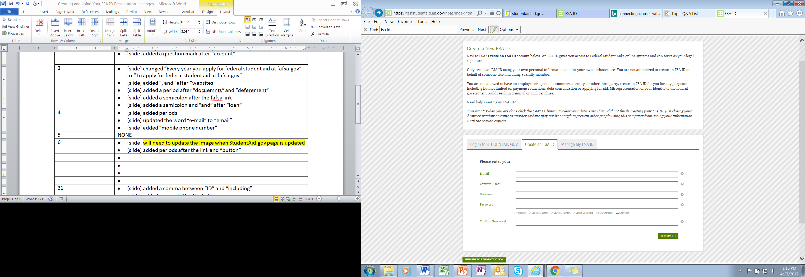

You can select “Show Text” to see what you’re typing.

**E-mail:**

* Each FSA ID must have a **unique** e-mail address (you and your parent cannot use the same e-mail address)
* You must have access to this e-mail account (this should be an account you will have access to after you graduate)

**Username:**

* If you see a message “Username taken, create a different username” as someone has already used that username
* Make sure your Social Security number, date of birth, and name match what’s on your Social Security card
* You must have a Social Security number to create an FSA ID.
* Confirm information you entered previously and provide additional information
* Make sure your information is correct; any errors could result in a delay or problem in your receiving financial aid (or the repayment of your federal student loans)

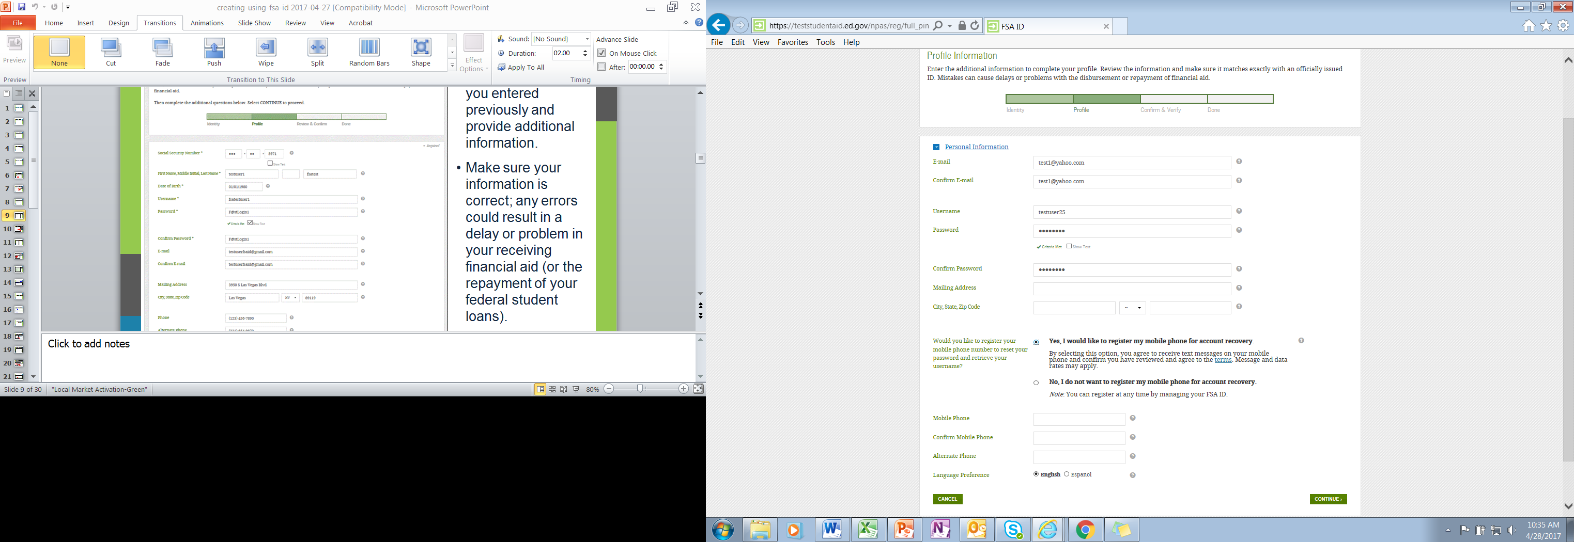

You can now register your mole phone number for account recovery.

* Confirm information you entered previously and provide additional information.
* Make sure your information is correct; any errors could result in a delay or problem in your receiving financial aid (or in the repayment of your federal student loans).

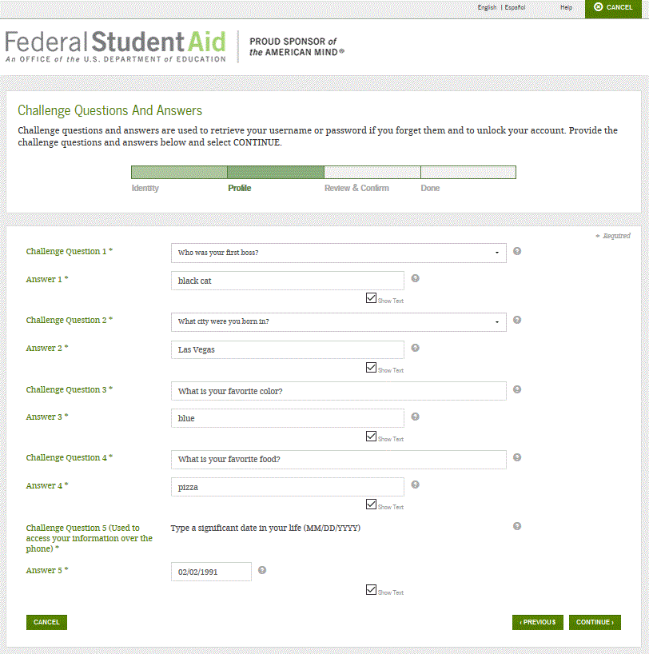

You can select “Show Text” to see what you’re typing

Answering your challenge questions is one way to unlock your account or reset your username and password

**Questions 1 and 2:**

* Select a question from the dropdown menu and then enter your answer

**Questions 3 and 4:**

* Make up your own question and enter your answer
* Make sure the answers will be easy to remember

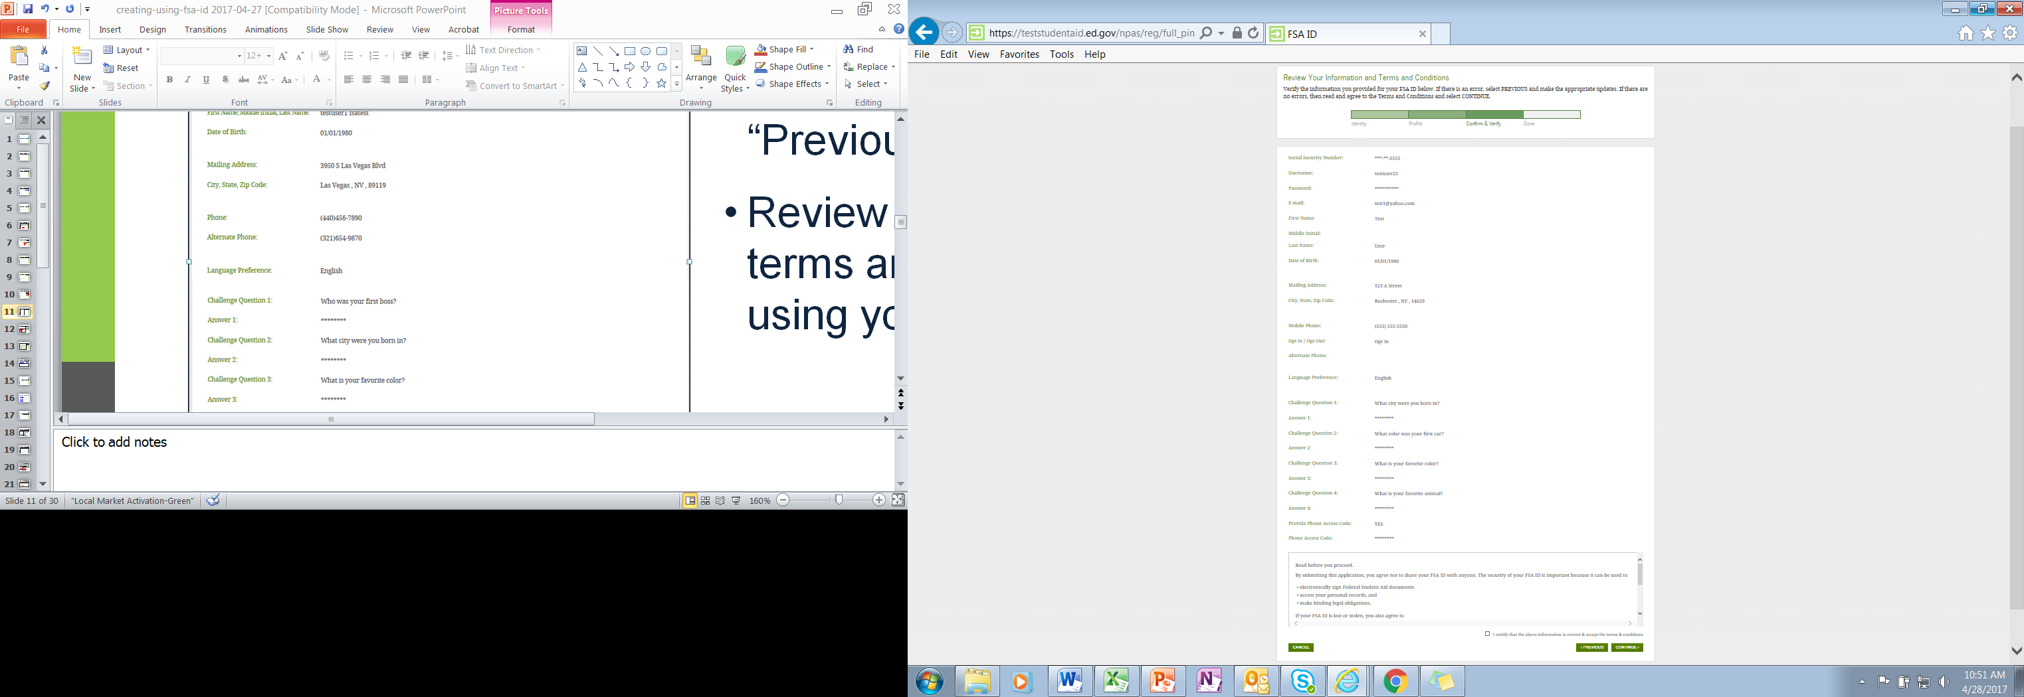

* Review and confirm your information
* If you need to make a correction, use the “Previous” button
* Review and agree to the terms and conditions for using your FSA ID

Verify Your Mobile Phone Number

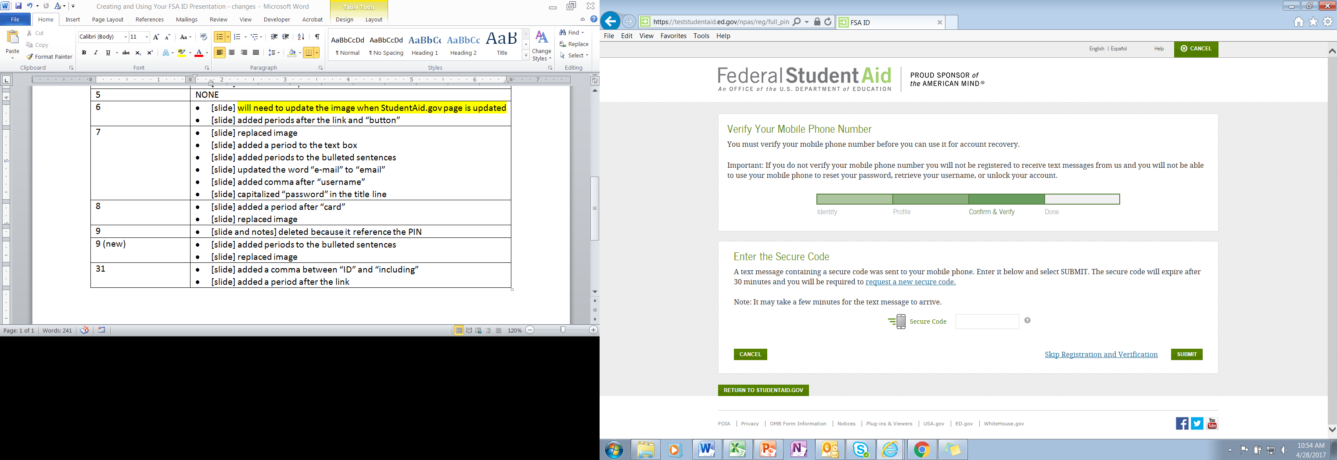

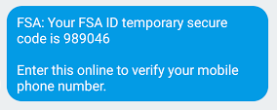

* If you provided a mobile phone number, you will be taken to this page
* One you verify your mobile phone number, you can use your phone to unlock your account, retrieve you user name, or reset your password.
* Do not close the mobile verification page until you have verified your number.
* You will receive a text with a 6 digit secure code to enter.

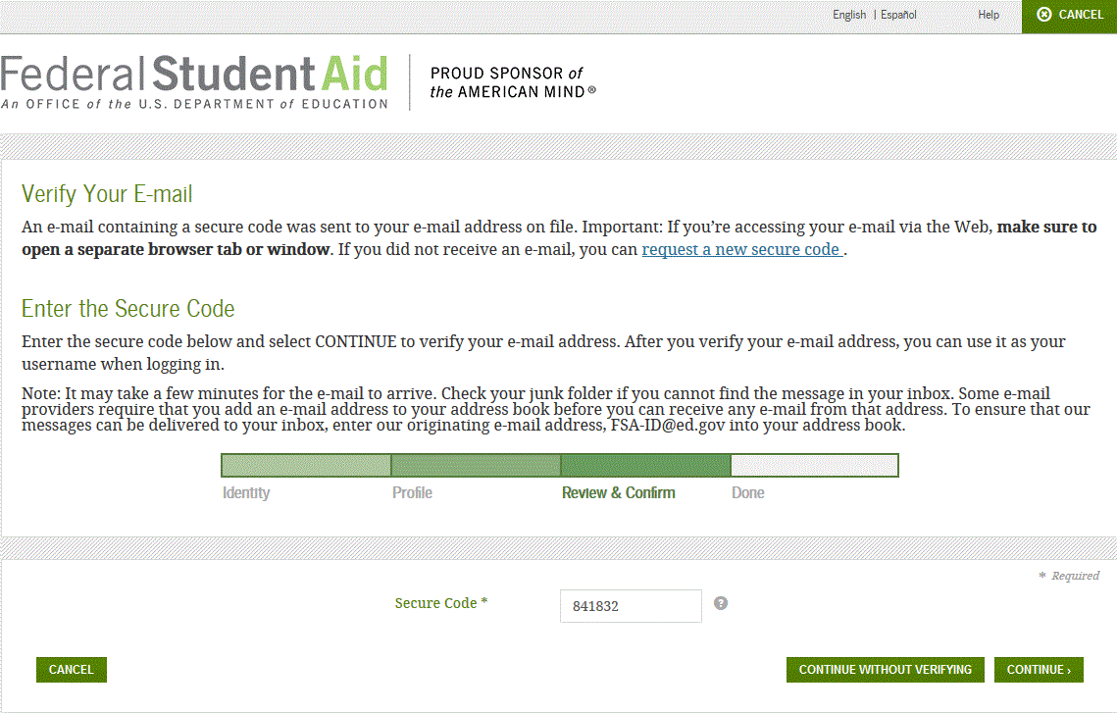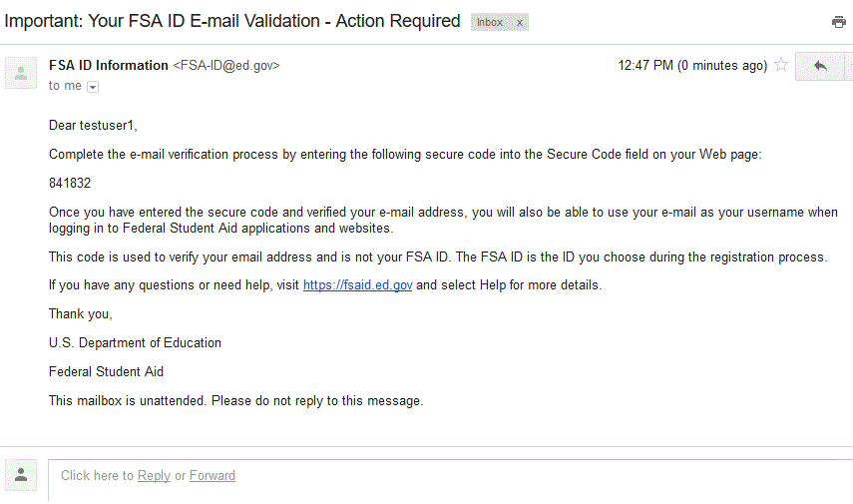

**E-mail Verification Page**

**E-mail with Your Secure Code**

* Once you verify your e-mail, you can use your e-mail address as your username when logging in to Department of Education websites
* You will also have the option to verify a cell phone number to retrieve you username if you forget it
* You can also continue without verifying

**How to Verify Your E-mail and/or Cell Phone Number**

* They will send you an e-mail you with a secure code
* Look for an e-mail with the subject line, “Important: Your FSA ID E-mail Validation - Action required”
* The e-mail will include a six-digit, numeric code that you will enter in the “Secure Code” data field

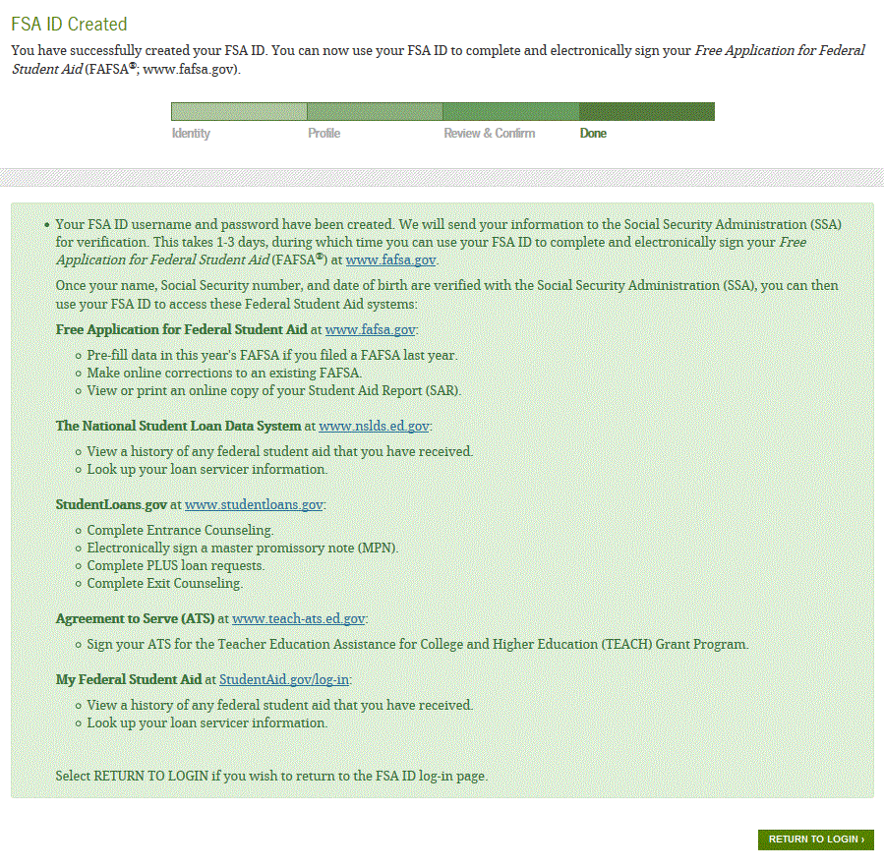

* If you provided an e-mail address, then you will receive a confirmation e-mail

**Using Your FSA ID**

* SSA review will take 1-3 days
* Until your info is verified, you won’t be able to take certain actions, such as correct your FAFSA or sign a Master Promissory Note.

You are Done!